Global Grant Project Update
Adopt Schools Alotenango (Guatemala) – Phase II
Rotary Foundation Global Grant #GG2352265
June 2025
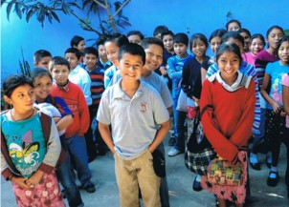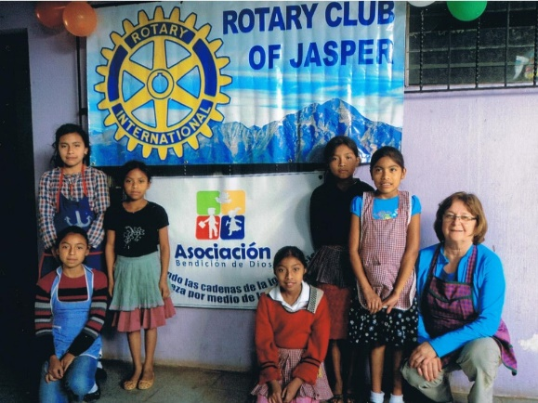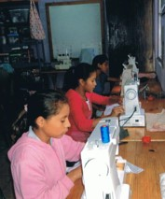
News Flash: our Rotary global grant project aimed at creating hope for a better world and reducing poverty in a low-income Central American Country was approved and funded in December 2024 after 2 years of planning, fundraising, application and approval!! Our project supports an education & literacy and economic & community development project in Alotenango (Guatemala) a rural farming community SW of Guatemala City with a population of 16,000+ people, 70% of whom are indigenos, there is a 35% literacy rate, and only 3 in 10 children graduate beyond grade 6!
Total Project funding approved was $91,732USD: with $39,156 from our Rotary Club funding partners, $26,709 in District 5370 Designated Funds (DDF), $2,500 DDF from District 5320, and $23,367 from the Rotary Foundation World Fund.
Thanks to all our generous Rotary Club Funding Partners – an amazing 16 Rotary Clubs as funding partners, providing critical funding support to help make this life changing project happen:
- 10 Clubs from Rotary D5370 including Jasper, Lloydminster, Slave Lake, Sherwood Park, Grande Prairie, Whitecourt, Drayton Valley, Edmonton Glenora, Dawson Creek Sunrise, and NW Spirit
- Club Rotario Nueva Guatemala in D4250,
- Rotary Clubs of Calgary Downtown and Calgary West from District 5360,
- Rotary Club of Nanaimo in District 5020,
- Rotary Club of Yorba Linda Sunrise (California) in District 5320, and
- Rotary Club Montreal Ville-Marie in District 7040.
Key project activities that are currently underway include the purchase of:
- furnishings for 5 classrooms (125 students) in the new Secondary School (Grades 7-9).
- computer equipment & furnishings for new 30 station computer lab.
- furnishings and A/V equipment for a new multi-purpose community meeting / school resource room.
- furnishings, filing cabinets, & computer stations for a new Administrative Office, and
- shoes for students, part of the Bendicion de Dios School Shoes for School Student Program to support families and students still impacted by COVID, as well as to ensure safety of students.
Next on the to do list of activities over the next year includes:
- a grand opening celebration of the new Secondary School in late July,
- the purchase of specialized equipment to support improvements to the vocational training programs, developing a broader range of saleable skills and services for both employment and successful small businesses by youth & adults, with a focus on sewing and beauty and hairdressing,
- purchase of equipment for the school kitchen improvements to increase capacity for breakfast and lunch programs for an additional 125 students, and
- provide teacher training workshops to maintain & improve skills of all teachers in Bendicion and Wisehart Schools, as well as advanced computer skills for Grade 7-9 teachers.
Our Project Partners include:
The Wisehart Charity, founded by Donnelly Hart, a Jasper Rotarian who has been working in Alotenango for the past 13 years and has partnered with Bendicion de Dios School since 2012. As a Canadian registered not-for-profit, Wisehart provides vocational education to the school and the community by offering cooking and sewing classes to the Grade 7-9 students, plus youth and adult classes (mostly women) for the community. The vocational programs, expanded in 2018-19 to include hairdressing, are geared towards knowledge & skills development, citizen engagement, service provision, employment creation, and investment strategies, all to create measurable and enduring economic improvements for these marginalized people.
Bendicion de Dios School, a not-for-profit school that offers basic education from pre-kindergarten to Grade 9 to poor children whose families cannot afford to send them to government-run public school. Bendicion has been in operation for the past 20-years and involves the family as a whole and has a student population of 500.
Club Rotario Nueva Guatemala (D4250) is a continued collaborator & supporter of this project, having co-hosted our TRF Global Grant in 2017-2020. They are very excited to be serving as host partner once again for this new TRF GG Project, expanding positive impacts and improving lives in Alotenango.
Rotary Club of Jasper (D5370) has been supporting Wisehart Charity and this project for 13 years, watching the benefits it has achieved for students, families, and community.
For more info: check out our project update in Rotary Service Project Center
Have questions, need more information, contact:
Donnelly Hart Libby Weir
Co-Chair, International Projects Committee Past President &
Rotary Club of Jasper & Co-Chair, International Projects Committee
President, Wisehart Charity Rotary Club of Jasper
Tel. 780-883-0244 Tel. 780-931-6249
Email: donnellyhart@gmail.com Email: libbyweir@shaw.ca
