Wolf Invitational Programming Contest
Plano West Senior High
Saturday, February 18, 2023, 8:30 am to 1:30 pm
Attendance Form
Plano West Senior High School invites you to the Annual Wolf Invitational Programming Contest. This is a 3-hour, hands-on, HP CodeWars-inspired contest. There is no written portion. The contest costs $45 per in-person team, which includes the programming contest and lunch. Virtual participants can participate for free but won’t receive trophies or lunch. There are approximately 25 problems ranging from the very easy to those challenging for even the best teams.
Schedule
8:30 – 8:45 | Team Check-in
8:45 – 9:15 | Dry Run
9:30 – 12:30 | Programming Contest – 3 hours!
12:30 – 1:00 | Lunch
1:00 – 1:30 | Awards and Prizes
Teams
- Teams consist of at most 3 students all from the same school
- Teams will be provided 1 computer that has access to the Java API
- Installed IDEs: JCreator, NetBeans, Eclipse intelliJ
- Solutions will be submitted using HackerRank
- Each team may bring one published reference book – no hand-written notes, pre-written code, or ChatGPT are permitted
Advanced or Novice Division?
- Each team must register as either the Advanced or Novice division as determined by their coach
- If at least 1 team member is considered Advanced, then the entire team competes in the Advanced division
- In general, students are considered Advanced if they have completed AP Computer Science and/or have contest experience prior to this year (thank you, Linda Woessner for a great guideline!)
- Any team may compete in the Advanced Division ☺
9/10 Division
- There will be an additional division for teams with only 9th or 10th graders
- Problems will be written by Mr. Yee
- There will be trophies for 1st, 2nd, 3rd, and 4th depending on the amount of teams
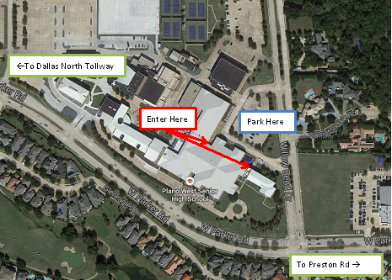
Awards
The top 4 teams in each division will receive a trophy and each team member will receive a medal.
Food & Drinks
We will provide pizza and bottled water for lunch for everyone. Students are welcome to bring their own snacks.
Location:
5601 W. Parker Rd, Plano, TX 75093

Corner of Parker Rd and Willow Bend Rd
This Entry is locked

